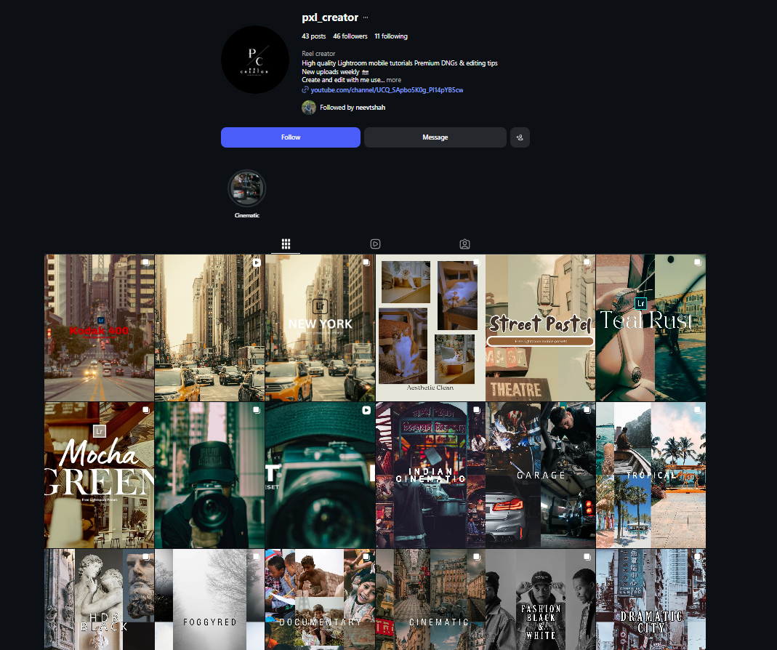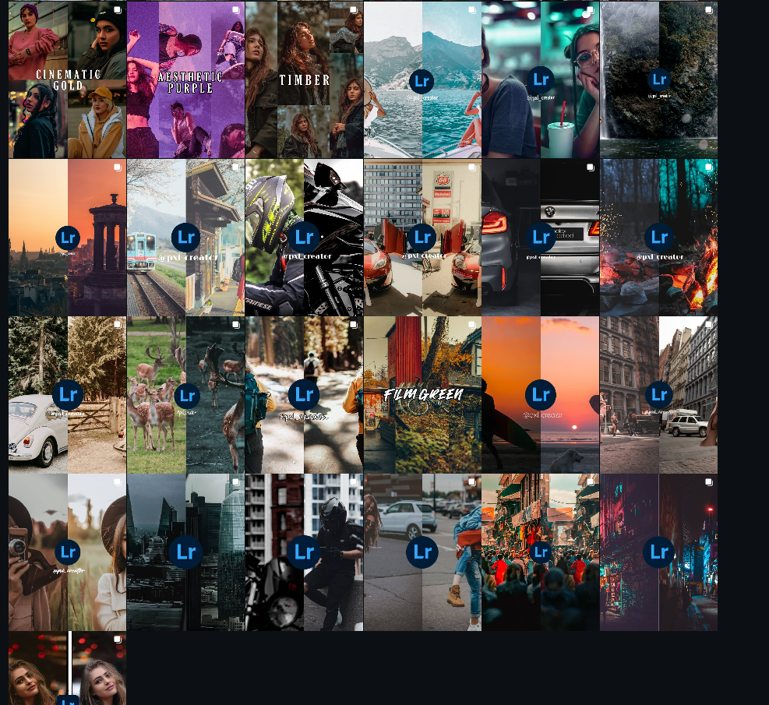

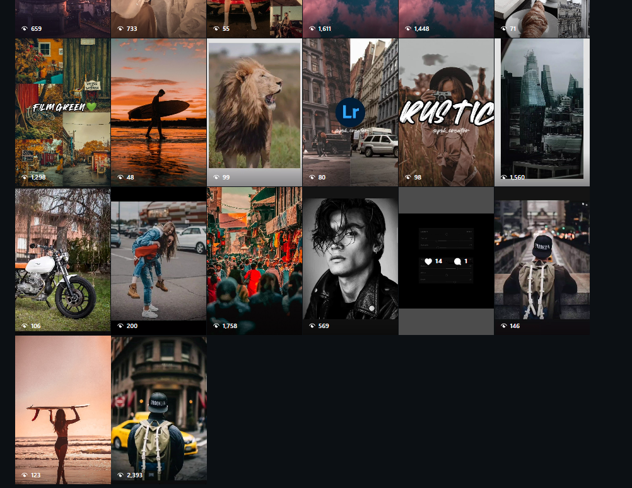
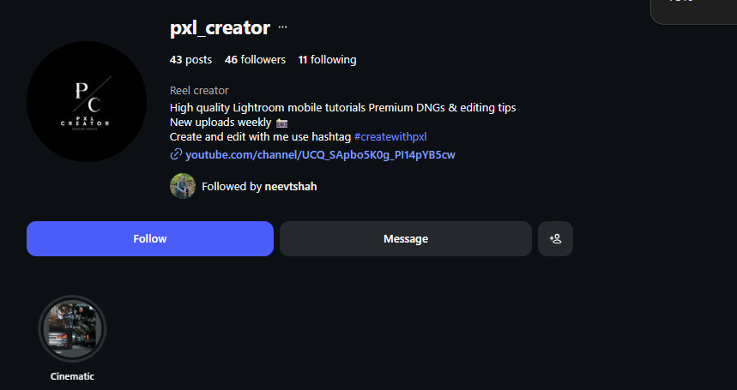
Highest view reel : https://www.instagram.com/reel/CNouoKFDigZ/?utm_source=ig_web_copy_link&igsh=MzRlODBiNWFlZA==
least viewd reel : https://www.instagram.com/reel/DL4WGbmOSAG/?utm_source=ig_web_copy_link&igsh=MzRlODBiNWFlZA==

